NAAN MUDHALVAN

TITLE : WORDPRESS CREATION

USER NAME : CB03D9275A8AE558C2F4B39295145681

1.open word press

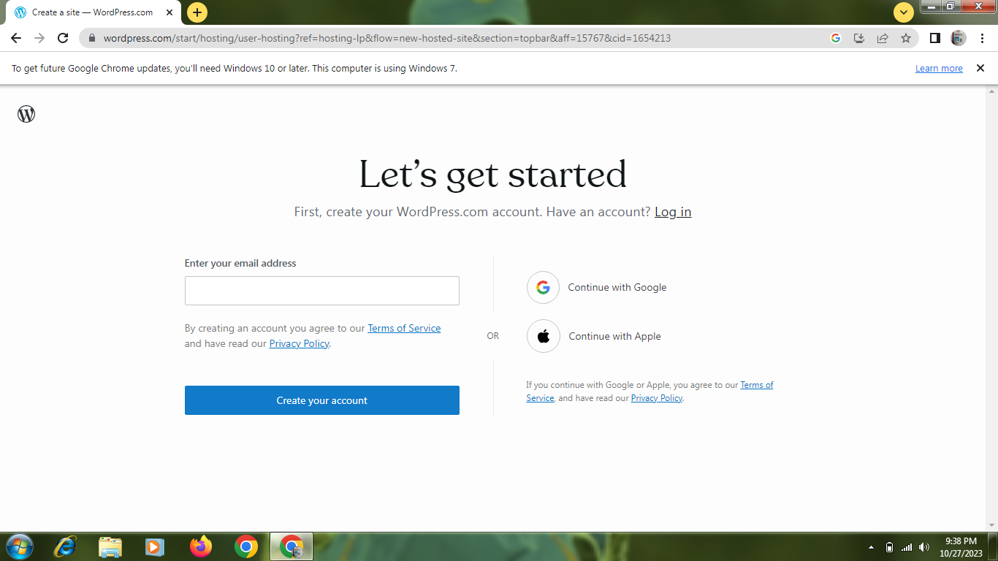

2.create a site and details

(1). Name

(2).site title

3.create a post

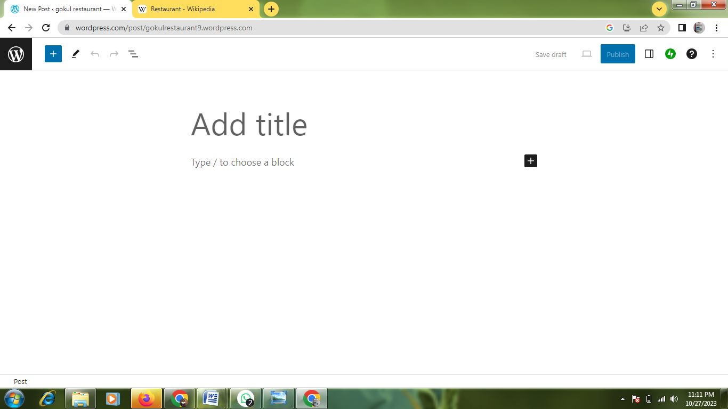

4.text the content

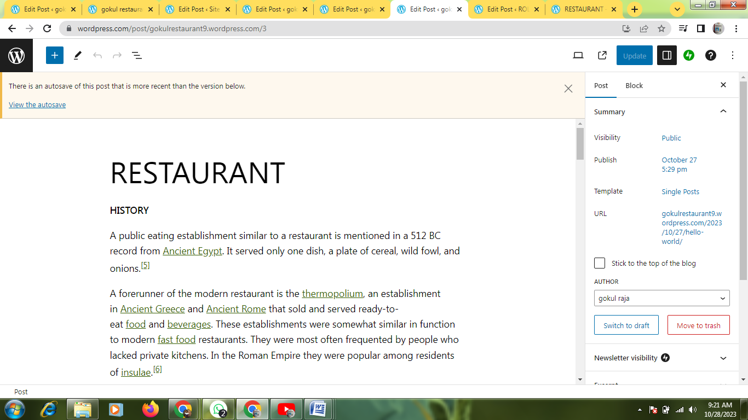

5.upload a post

